Celebrating Wellness Week in New Brunswick
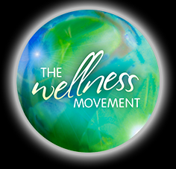
October 1st-7th is Wellness Week in New Brunswick and this year’s theme is Start Your Story.

During the first week of October, Wellness Week activities will be taking place in many communities across New Brunswick to recognize current efforts in promoting wellness.
Here are some things that you can do to add to your family’s wellness story:

- October is International Walk to School Month- Consider walking; at least part of the way, to school with your child. Take turns with other adults in your community to walk the children to school. For more ideas visit: www.saferoutestoschool.ca

- Have a green day! Encourage everyone to wear green, bring a green vegetable or fruit for lunch and help the environment by composting and recycling. Pack eco-friendly lunches where nothing goes in the garbage.

- Have a salad day. Look for local vegetables such as lettuce, tomatoes, cucumbers, beets, broccoli, cabbage or carrots. Have everyone in the house wash and chop a different vegetable and see how colourful you can make your salad. To find local products, check out: www.buylocalnb.ca/

- Send positive messages to your family and friends. Leave a note on a mirror or in your child’s lunch bag. Share positive stories at the dinner table.

- Explore the outdoors. Go on a family walk, enjoying the fall colours as well as the sounds and smells of nature.

If you are looking for other ideas or inspiration visit: http://www.wellnessnb.ca/start-your-story/.

September is also Breakfast for Learning month. Encourage a healthy breakfast each day including at least three of the four food groups in Canada’s Food Guide.

Dietitians, Public Health, Horizon Health Network, area 3.

